**Global CO2 Emissions Tracker by Sector**

**Policy Brief**  
*Date: 29-06-2025*  
*Prepared by: NEHA NEGI*

**Executive Summary**

This report presents an analysis of carbon dioxide (CO2) emissions across the Energy, Transport, and Industry sectors globally. Utilizing multi-year data, it highlights key polluters, emissions trends, and the implications of per capita and GDP-adjusted metrics. The insights aim to guide policymakers toward effective, sector-specific climate action.

**Key Findings**

* **Dominant Emission Sources:**  
  The Energy sector leads global CO2 emissions, followed by Transport and Industry. Major emitters include China, the United States, and India.
* **Adjusted Metrics Provide Context:**  
  Per capita emissions reveal high carbon footprints in smaller developed nations, while emissions per GDP show progress or lack thereof in decoupling economic growth from emissions.
* **Emission Trends:**  
  Several developed countries demonstrate declining emissions intensity, whereas many developing nations show rising emissions aligned with industrialization and urbanization.

**Visual Highlights:**

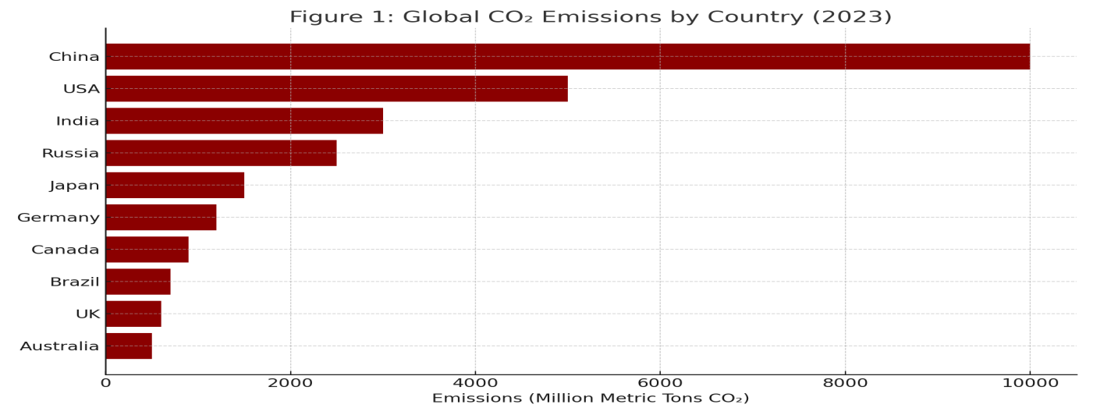

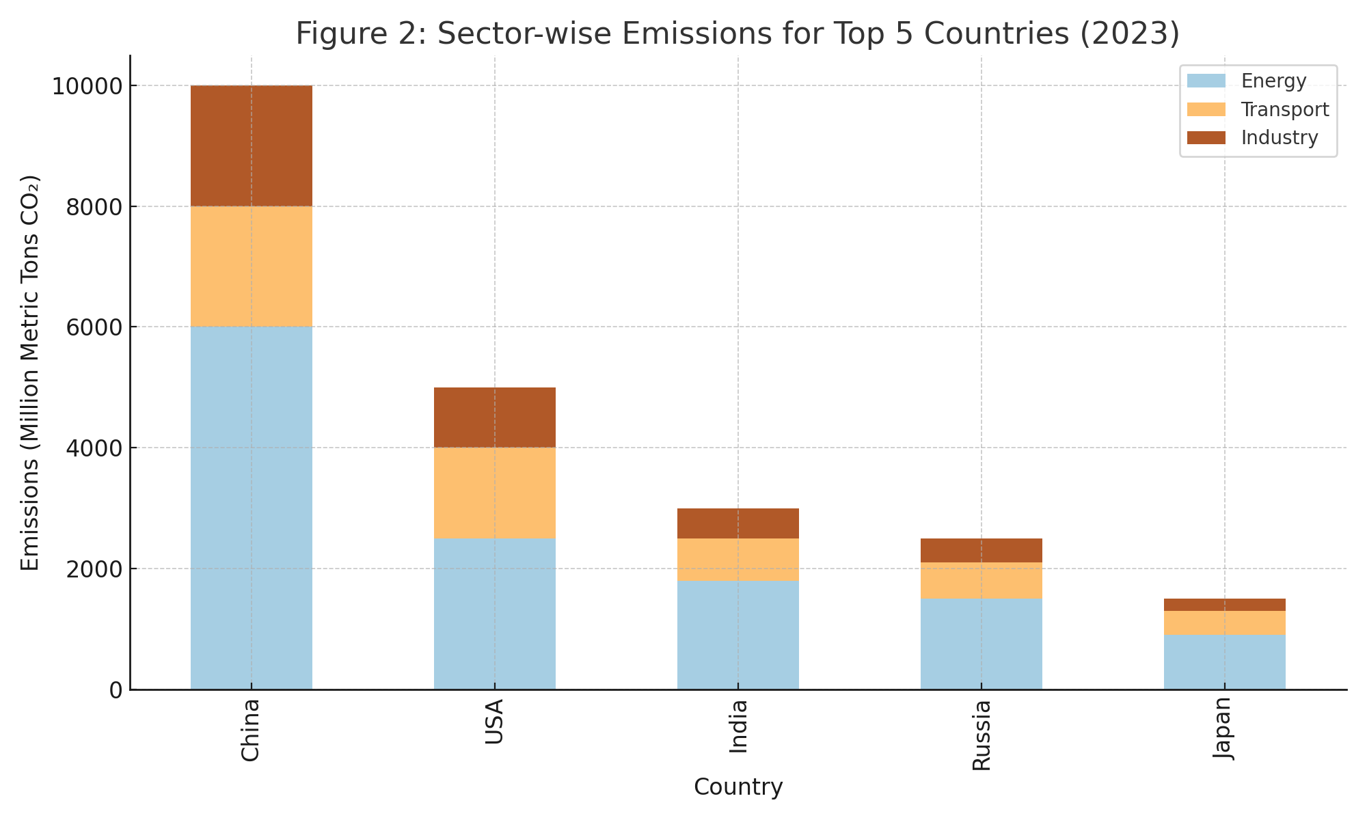

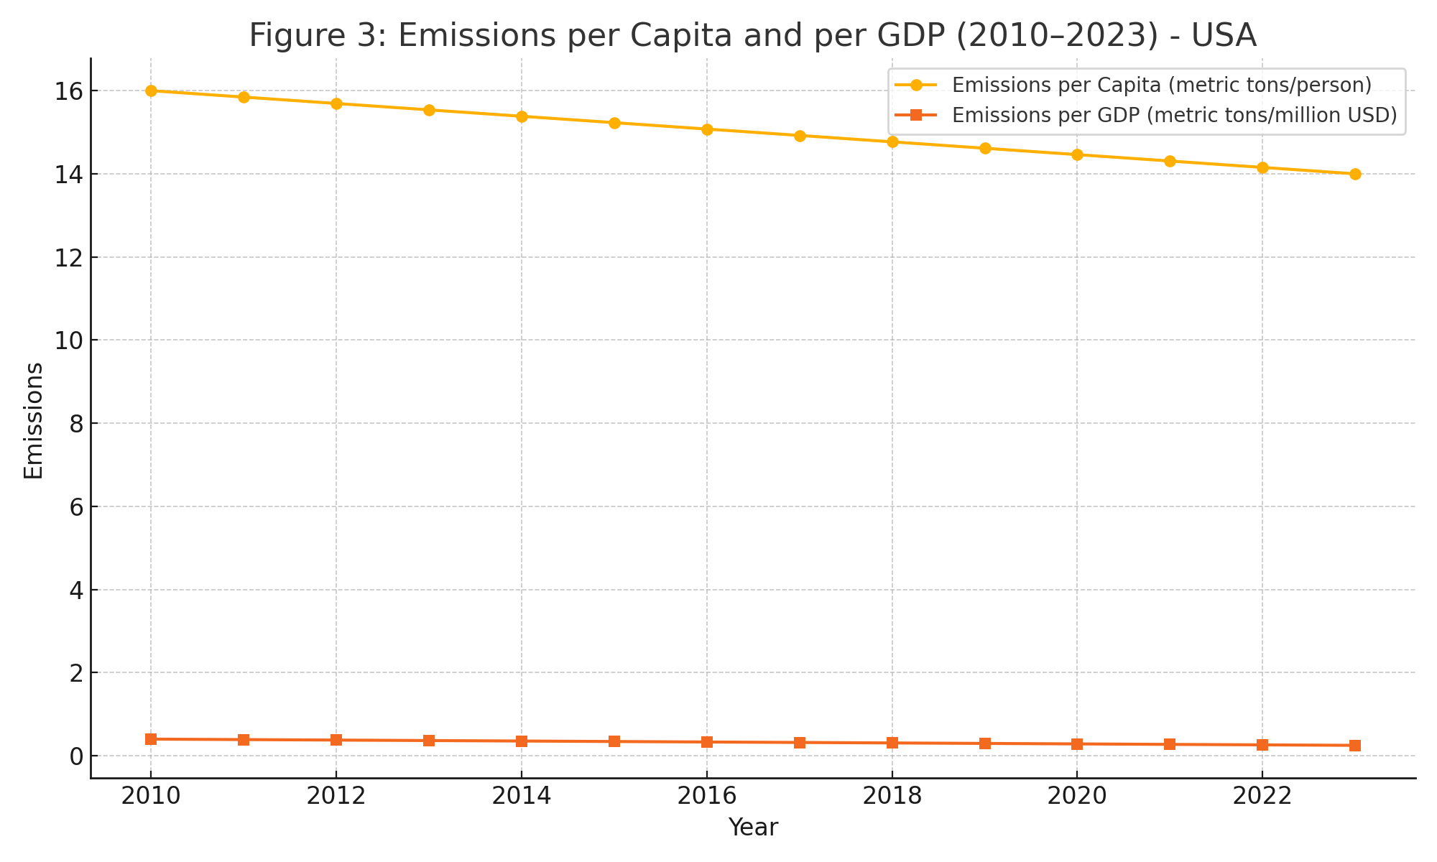

**Policy Recommendations**

* **Energy Sector Reforms:**  
   Accelerate renewable energy adoption and phase out coal-based power generation.
* **Sustainable Transport Development:**  
   Expand public transit, incentivize electric vehicles, and impose stricter emission standards.
* **Industrial Emission Controls:**  
   Promote energy-efficient industrial processes through regulations and subsidies.
* **International Collaboration:**  
   Support technology transfer and financial aid to emerging economies.
* **Equity-Based Metrics:**  
   Use per capita and GDP-adjusted emissions to craft fair, effective policies.

**Conclusion**

* Robust data tracking and sector-specific policies are crucial to achieving global emission reduction targets. This emissions tracker provides an essential tool for monitoring progress and informing evidence-based climate strategies.